**HW4:Solutions**

**SDGB 7844: Statistical Methods and Computation I**

**Minxia Ji**

**Question 1**

For the reduced data set,

The first date is:2003-01-08

The last date is:2014-10-29

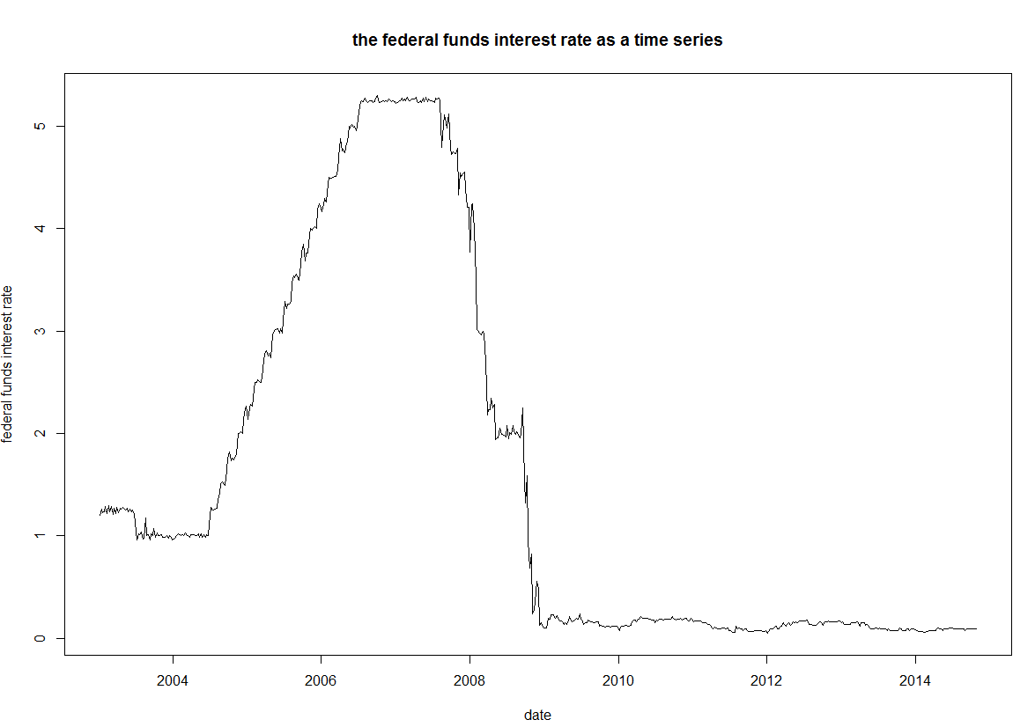

The federal funds interest rate was about 1% from 2003 to 2004, then went up rapidly from 2004 to 2006 and reached the peak over 5%.It kept stable in the period from 2006 to 2008.Suddenly, the rate dropped dramatically in 2008 because the **financial crisis** happened.Since then, the federal funds interest rate became stale at roughly 0%.

**Question 2**

There are **570** observations in the training data set and **43** observations in the testing data set.

**Question 3**

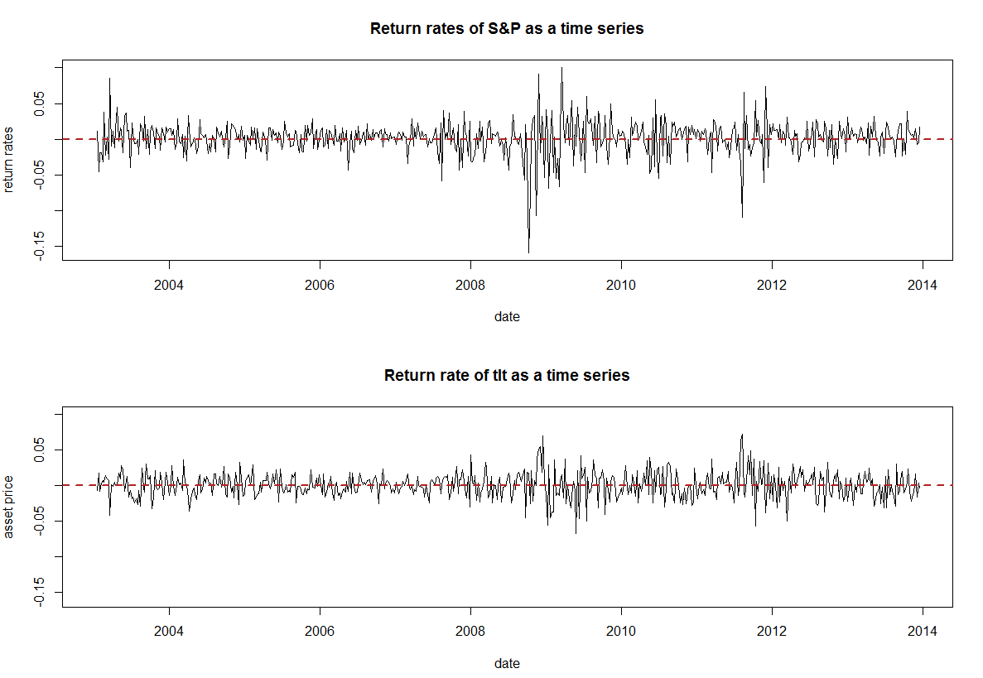

Comparing the returns of two assets as time series plots, we can see that most of lines of both plots fluctuates in -0.05 to 0.05.S&P 500 assets have larger lower and upper limitations. We can conclude that the returns for S&P 500 assets is **more volatile** compared to the returns of long term treasury bonds ETF assets.

**Question 4**

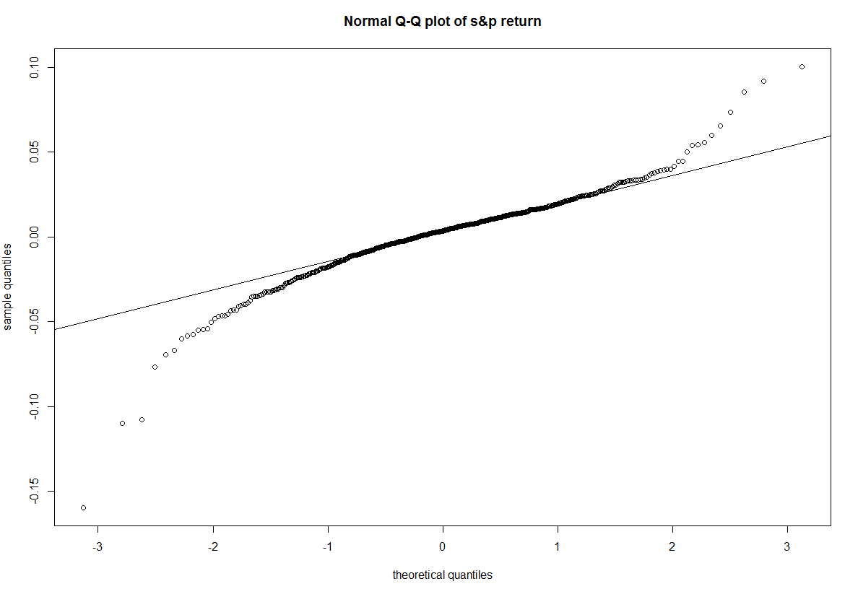

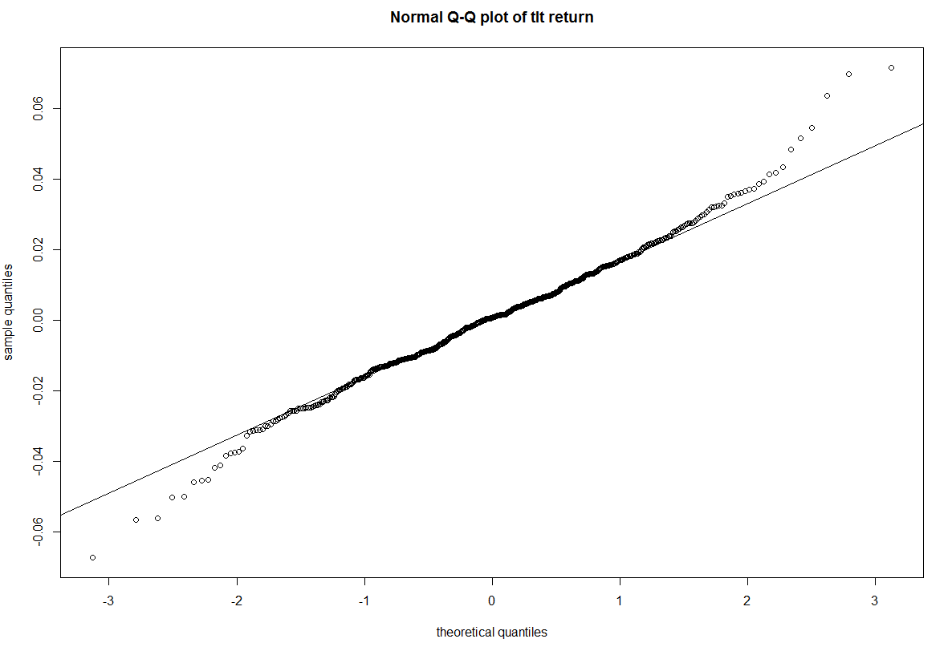

This assumption is **not** satisfied. The observations do not form a straight line. This has an S-shaped which means it comes from a heavy-tailed distribution.

**Question 5**

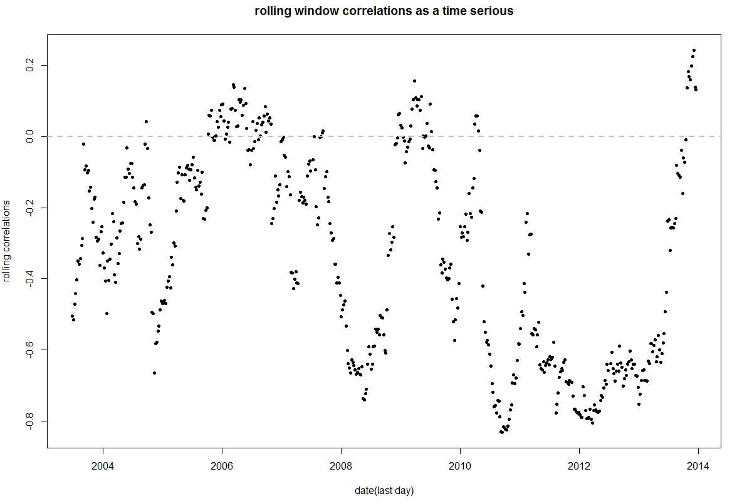

Correlation is:-0.3439013.

The **rolling-window correlation** is a better way to describe the relationship between these two assets.From the plot, we can see the variation between different periods. The correlation between these two assets only tells us that the two have a negative correlation in 2003-2014; But, the rolling-window correlation shows the variation between different periods. For example, there was a strong negative correlation in 2011, almost no correlation in 2006 or a positive correlation in 2009. Thus, rolling-window correlation can help us better understand the relationship between these two assets.

**Question 6**

Sharp ratio of S&P asset:0.2807176

Sharp ratio of tlt asset:-0.01095925

Obviously, **S&P asset** is a better investment.

**Question7** 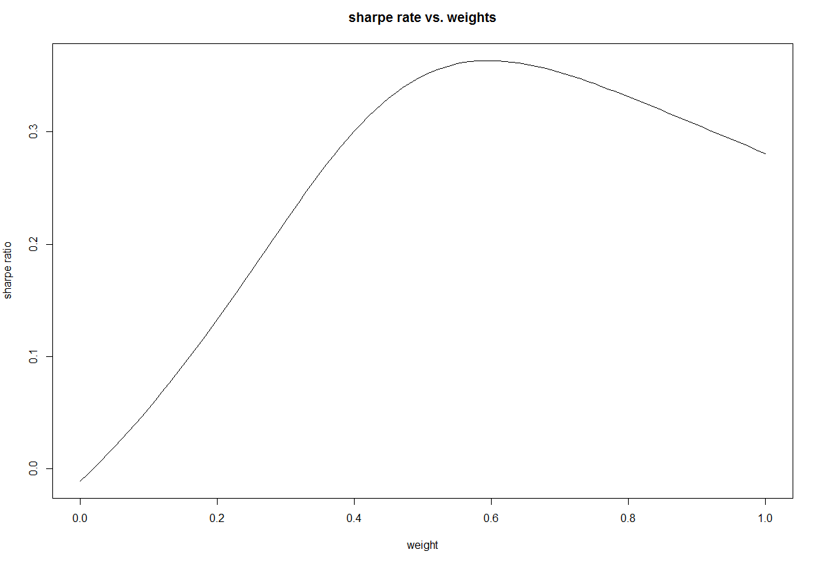

I saw the weight that produces the maximum Sharpe ratio.The weight of x near 0.6, 60%.

**Question 8**

59.58502% of the funds should be allocated to S&P500 asset and 40.41498% of the funds should be allocated to long term treasury bond ETF assets.The Sharpe ratio of the overall portfolio is 0.3634139.

The best choice is to invest the **combined portfolio**.Since the Sharpe ratio of combined portfolio is the highest among these three choice.To invest in S&P500 only(0.2807176), long term treasury bonds only(-0.01095925), or combined portfolio(0.3634139).

**Question 9**

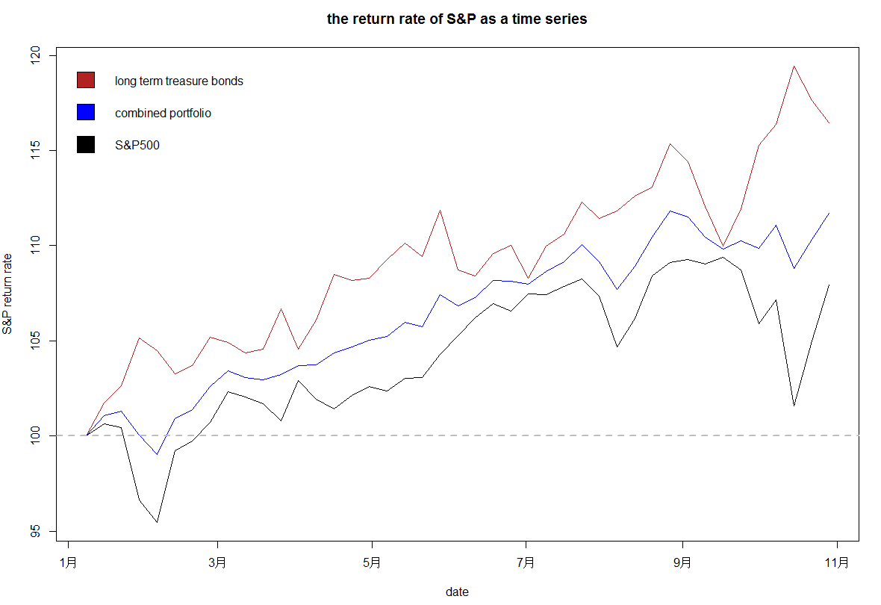

The excess returns index for long term treasury bond ETF assets always dominates the other two.The excess returns index for combined portfolio is always between that for investing in S&P500 assets and that for investing in long term treasury bond ETF assets. In addition, the excess returns index for combined portfolio is more stable than the other two.

**Question 10**

If you invested $100 in each asset (portfolio,all in long term treasury bonds, or all in S&P500) in the first week of January, 2014, you will receive $107.8763 for investing in S&P500, $116.376 for investing in long term treasury bonds and $111.6367 for investing in combined portfolio at the end of the test set period for each asset in addition to the risk-free interest rate.

My portfolio performed well in the test set because it is profitable.Investing 100 and I can get 111.6367 at the end of test data period, the return rate is 11.6367% is considerable.